

**Project Document**

**Name :Sanjay kumar S**

**Register Number :720722106033**

**Department :ECE A**

**Year :II YEAR**

**Project Title**

**FOOD DELIVERY APPS**

**Template Name**

**LEAN UX CANVAS**

**Problem Statement**

**· Offers and discounts vary from one website to other.**

**· Delivery time is not constant.**

**· Orders are cancelled abruptly.**

**· Refunds take lot of time.**

**· Good food quality assurance is not there.**

**· Proper list of ingredients not present.**

**Project description**

**1. User-Friendly Interface:**SavoryDelight boasts a user-friendly interface that makes ordering food a breeze. Users can easily browse through a wide range of restaurants, cuisines, and dishes with just a few taps.

**2. Customizable Orders:** Whether you have dietary restrictions or specific preferences, SavoryDelight allows users to customize their orders according to their needs. From extra cheese to no onions, users have the freedom to tailor their meals to perfection.

**3. Real-Time Tracking:** Say goodbye to the anxiety of wondering where your food is. SavoryDelight offers real-time tracking, allowing users to monitor the status of their orders from preparation to delivery, ensuring transparency and peace of mind.

**4. Secure Payment Options:** With SavoryDelight, users can enjoy a variety of secure payment options, including credit/debit cards, digital wallets, and cash on delivery, making transactions hassle-free and secure.

**5. Reviews and Ratings:** Make informed decisions with the help of reviews and ratings from fellow users. SavoryDelight provides a platform for customers to share their experiences and recommendations, helping others discover the best restaurants and dishes in town.

**Worked Template with explanation**

**User Registration:** To use the app, users need to create an account. They usually provide basic information such as name, email address, and phone number. Some apps also offer social media login options for convenience.

***Browsing and Selection*:** Once logged in, users can browse through a list of restaurants available for delivery in their area. They can filter restaurants based on cuisine, ratings, delivery time, and more. Each restaurant listing typically includes menus, prices, reviews, and ratings.

***Menu Selection and Customization:*** *Users can select items from the menu of their chosen restaurant. Food delivery apps often allow for customization of orders, such as specifying toppings, sauces, or sides. Users can add items to their virtual cart as they browse.*

***Order Placement*:** *After finalizing their order, users proceed to the checkout process. Here, they can review their order summary, select a delivery address (which may be saved for future orders), and choose a payment method.*

***Payment Processing*:** *Food delivery apps offer various payment options, including credit/debit cards, digital wallets (e.g., Apple Pay, Google Pay), and cash on delivery. Users enter their payment details securely within the app.*

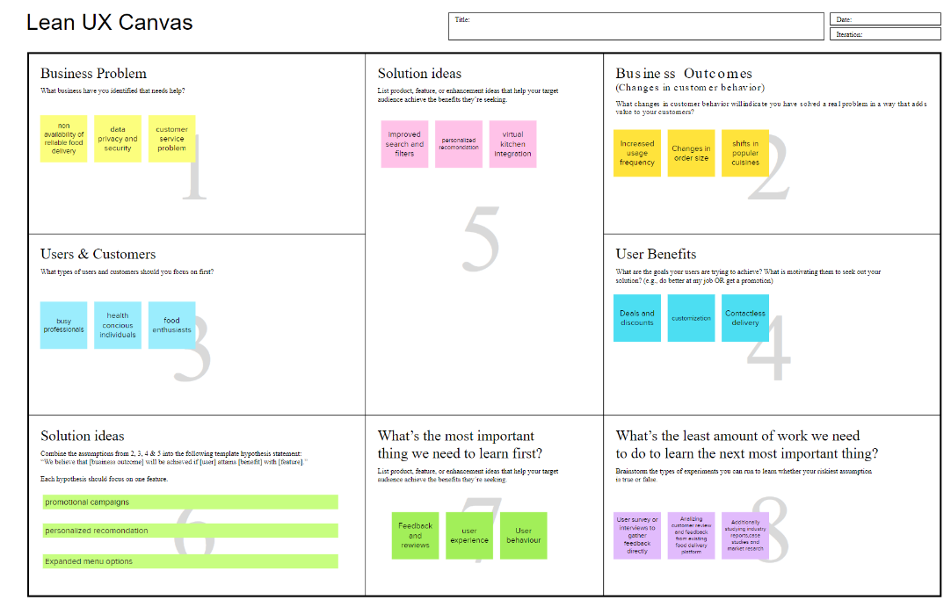

**GitHub Link:**

**https://github.com/sanjaykumar33/IBM.git**